SENIOR PASTOR, full-time

KOLOA MISSIONARY CHURCH - Koloa, Kauai, Hawaii

Koloa Missionary Church, with a congregation of about 70, is seeking a senior pastor who is grounded in The Word and devoted to prayer to love, shepherd and equip our committed and multi-generational family of Christ-followers to be effective disciplers.
Who We Are:
We believe the Bible to be the divinely inspired Word of God and our authority. We believe that prayer is our vital communication link with God. (Details on 2nd page).
Our 67-year old church is the first to have been established in Hawaii by missionaries from the Missionary Church denomination headquartered in Indiana. Many of our denomination’s Hawaii pastors were raised up in this church or are their spiritual offspring.
Our original church facility was formerly a clinic and hospital built in the late 1800s to provide physical restoration to individuals in this plantation community at that time. Acquiring the property in 1953, Koloa Missionary Church became a source of spiritual restoration in the Koloa community.
In 2007, we trusted the Lord’s leading to build a new church facility due to the high cost of constant repairs to our beloved but aged structure and to be able to more effectively serve our community. Soon thereafter, we launched our BUILDING LIVES capital campaign. Then in 2011, we deconstructed/recycled our old building and broke ground for our almost three times larger new facility. After 3 years of devoted effort by mostly volunteers representing all walks of life, we dedicated God’s new facility in February 2014, debt free, to be used to bless others as we help BUILD LIVES.
APPLICANTS: Before applying please read the Missionary Church Articles of Faith and Practice contained in our Constitution found on the MCUSA.org website at: https://www.mcusa.org/wp-content/uploads/2020/04/CONST-10-19-final.pdf pages 4 - 10

If after reading our Constitution you feel our beliefs align, please immediately send a cover letter (that includes reason for your interest, your salary expectation, videos of or links to a sampling of your recorded messages, and describe any Kauai connection you may have), along with your current resume to: jmiyamoto@outlook.com
The final candidate will need to apply for license with the Missionary Church denomination and must subsequently fulfill requirements for ordination.
We will begin reviewing applicants in November, so please respond immediately. We thank you in advance for your time and interest, and your patience during our process.

Mahalo, The Koloa Missionary Church Pastoral Search Committee

∞∞∞∞∞∞∞∞∞∞∞∞∞∞∞∞∞∞∞∞∞∞∞∞∞∞∞∞∞∞∞
KOLOA MISSIONARY CHURCH
Purpose: To glorify God
Vision: Love God...Love one another
Mission: Be disciples…Make disciples

Our Core Values
Prayer: We believe that prayer develops our relationship with God and expresses our dependence on Him to accomplish His purposes.
The Word: We believe that Jesus is the Living Word and the Bible is the basis of our faith and practices.
Love: Because God loves us, we will demonstrate His love to others.
Grace: We believe that salvation comes by Grace. We also believe that spiritual growth and maturity come by Grace.
Worship: We believe Worship is expressing our love for God by acknowledging who He is and what He has done for us.
Transformed Lives: We desire our lives to be changed to become more like Christ through the power of the Holy Spirit.

∞∞∞∞∞∞∞∞∞∞∞∞∞∞∞∞∞∞∞∞∞∞∞∞∞∞∞∞∞∞∞
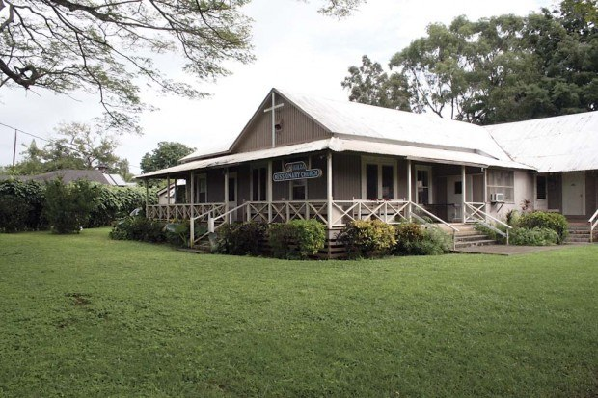
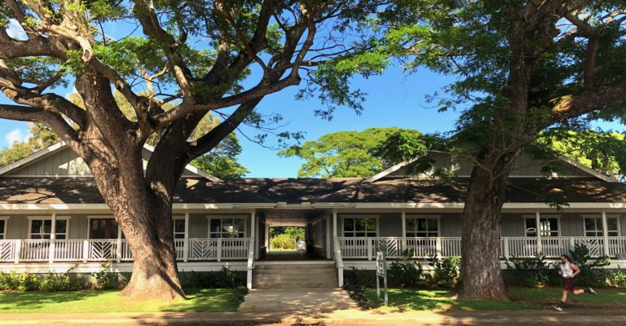
Circa 2000
Present Day
Rev 2020-10

